IT in [Automobile/Metro Rail/Avionics]

**Applying Design Thinking**

Empathize: Understand the needs and challenges of users and stakeholders in the [Automobile/Metro Rail/Avionics] industry.

Define: Clearly define the problem statement and objectives of integrating IT in [Automobile/Metro Rail/Avionics].

Ideate: Brainstorm ideas and potential IT solutions that can address the identified needs and challenges.

Prototype: Develop prototypes of the proposed IT solutions to visualize and test their feasibility.

Test: Gather feedback from users and stakeholders to refine the IT solutions.

**Identifying Stakeholders**

Primary Stakeholders: Manufacturers, operators, drivers, passengers

Secondary Stakeholders: Regulatory bodies, maintenance personnel

Stakeholder Analysis: Analyze the impact of IT integration on each stakeholder group and their interests and concerns.

Procedure for the Project

Research: Conduct thorough research on the current state of IT integration in the [Automobile/Metro Rail/Avionics] industry.

Requirement Gathering: Gather requirements from stakeholders and define the scope of the IT project.

Development: Develop the IT solutions based on the defined requirements and design thinking principles.

Testing: Test the IT solutions to ensure they meet the specified requirements and are user-friendly.

Deployment: Deploy the IT solutions in the [Automobile/Metro Rail/Avionics] industry.

Monitoring and Evaluation: Monitor the performance of the IT solutions and evaluate their impact on the [Automobile/Metro Rail/Avionics] industry.

**Product/IT Solution Features**

Integration with Existing Systems: Ensure seamless integration with existing systems in the [Automobile/Metro Rail/Avionics] industry.

Real-time Data Analysis: Provide real-time data analysis capabilities to improve decision-making.

Enhanced Safety and Efficiency: Improve safety and efficiency in the [Automobile/Metro Rail/Avionics] industry through IT solutions.

User-Friendly Interface: Ensure the IT solutions have a user-friendly interface for easy adoption by stakeholders.

Scalability: Design IT solutions that are scalable to accommodate future growth and technological advancements.

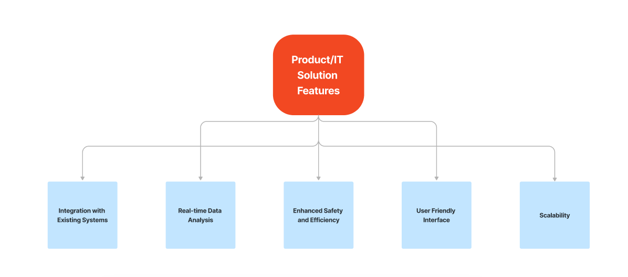

Regulatory Bodies

Maintenance Personnel

Passengers

Operators

Drivers

Manufacturers

Secondary Stakeholders

Primary Stakeholders

**Identifying Stakeholders**